**GRAPHIC ERA UNIVERSITY, DEHRADUN**



**A MINI PROJECT REPORT**

**ON**

**STUDENT PROJECT ALLOCATION SYSTEM**

**Submitted To: Submitted By:**

**Department Of Computer Science Aniket Aggarwal**

**And Engineering, Graphic Era University**

**University Roll no: 2014366 Semester: 5 (CSE)**

**Session: 2021-2022 Section: A**

**CONTENTS**

|  |  |  |
| --- | --- | --- |
| **SR NO.** | **INDEX** | **PAGE NO.** |
| **1** | **ABSTRACT** | **3** |
| **2** | **INTRODUCTION** | **3** |
| **3** | **MOTIVATION** | **4** |
| **4** | **PROBLEM STATEMENT** | **4** |
| **5** | **METHODOLOGIES** | **5-6** |
| **6** | **SYSTEM REQUIREMENTS** | **6** |
| **7** | **SCREENSHOT** | **7** |
| **8** | **RESULT ANALYSIS** | **8** |
| **9** | **REFERENCE** | **9** |

**ABSTRACT**

**The main idea behind designing this project is to allocate projects as per their work of their interest and under which mentor they desire to work. Manually project allocation and maintain its information becomes a tedious task for a person to avoid this and reducing workload of project allocator, this project provides an efficient and clean way to assign project according to the interests of students and maintain their database. It provides the interactive interface to the user and ensures that only allowed users can access this site by entering their provided credentials by the organization.**

**INTRODUCTION**

**Students are required to work on the projects to give students something of a choice, there should be as wide a range of available projects as possible, and sufficient number of projects should be available for students to select, project should not be less than the total number of students. There may also be bound must exist on the number of students that can be assigned to a particular project, and the number of faculty should be specific who can proposed the project.**

**MOTIVATION**

In the present Student Project Allocation system, each institute maintains information manually into the register. Storing the information manually in the register required a high amount of time and if the information is stored, then accessing that information is a time taking process as one need to search for the required information in each register. Where to store the information is time taking process it also increases the possibility of error in the data writing in registers. The information can be misplaced after some time as there are a lot of other registers are kept in the same place.

The proposed Student Project Allocation system is based on the internet so that data can be accessed by any system and from any place. The institute will need to enter the student information into the system so that whenever they require the information they can access by simply entering the student id or name into the system. The Student Project Allocation system will contain all the information of students such as academic, address, phone number etc.

**PROBLEM STATEMENT**

**The traditional way of allocating project to students in our higher institution have to be reconsidered since project or research writing is sensitive aspect of student education within the higher institution. At the start of graduating semester, the scholars are required to write down project on their field of study as a part of a requirement to complete the educational studies. Each student is allocated to a supervisor who will supervise the tutorial project to boost correctness and academic acceptability of the project work.**

**METHODOLOGIES:-**

* **PHP**

**It is a server side scripting language used for web development, basically used as backend language. It helps to connect to the DBMS to store and fetch information.**

* **MYSQL**

**To design the database, to store data in tabular form to make access time faster, and help inserting, updating, modifying the existing record in the table.**

* **BOOTSTRAPS**

**This is a framework used for faster implementation of html, css, java script code for project purpose. It consists of various components.**

* **Buttons -** Bootstrap includes several predefined button styles, each serving its own semantic purpose, with a few extras thrown in for more control
* **Modal -** Use Bootstrap’s JavaScript modal plugin to add dialogs to your site for lightboxes, user notifications, or completely custom content.
* **Navbar -** Documentation and examples for Bootstrap’s powerful, responsive navigation header, the navbar. Includes support for branding, navigation, and more.

**SYSTEM REQUIREMENTS**

**HARDWARE:-**

* **Operating System**
* **PROCESSOR: INTEL® PENTIUM® CPU @ 2.0 GHZ**
* **RAM: 2 GB**
* **STORAGE: 20 GB(Minimum)**

**SOFTWARE:-**

* **Visual Studio(IDE)**
* **Xampp control panel**
* **Browser**

**FEATURES:-**

* **INTERACTIVE**
* **USER FRIENDLY**
* **INEXPENSIVE**
* **ACCESSIBLE**

**SCREENSHOTS:-**

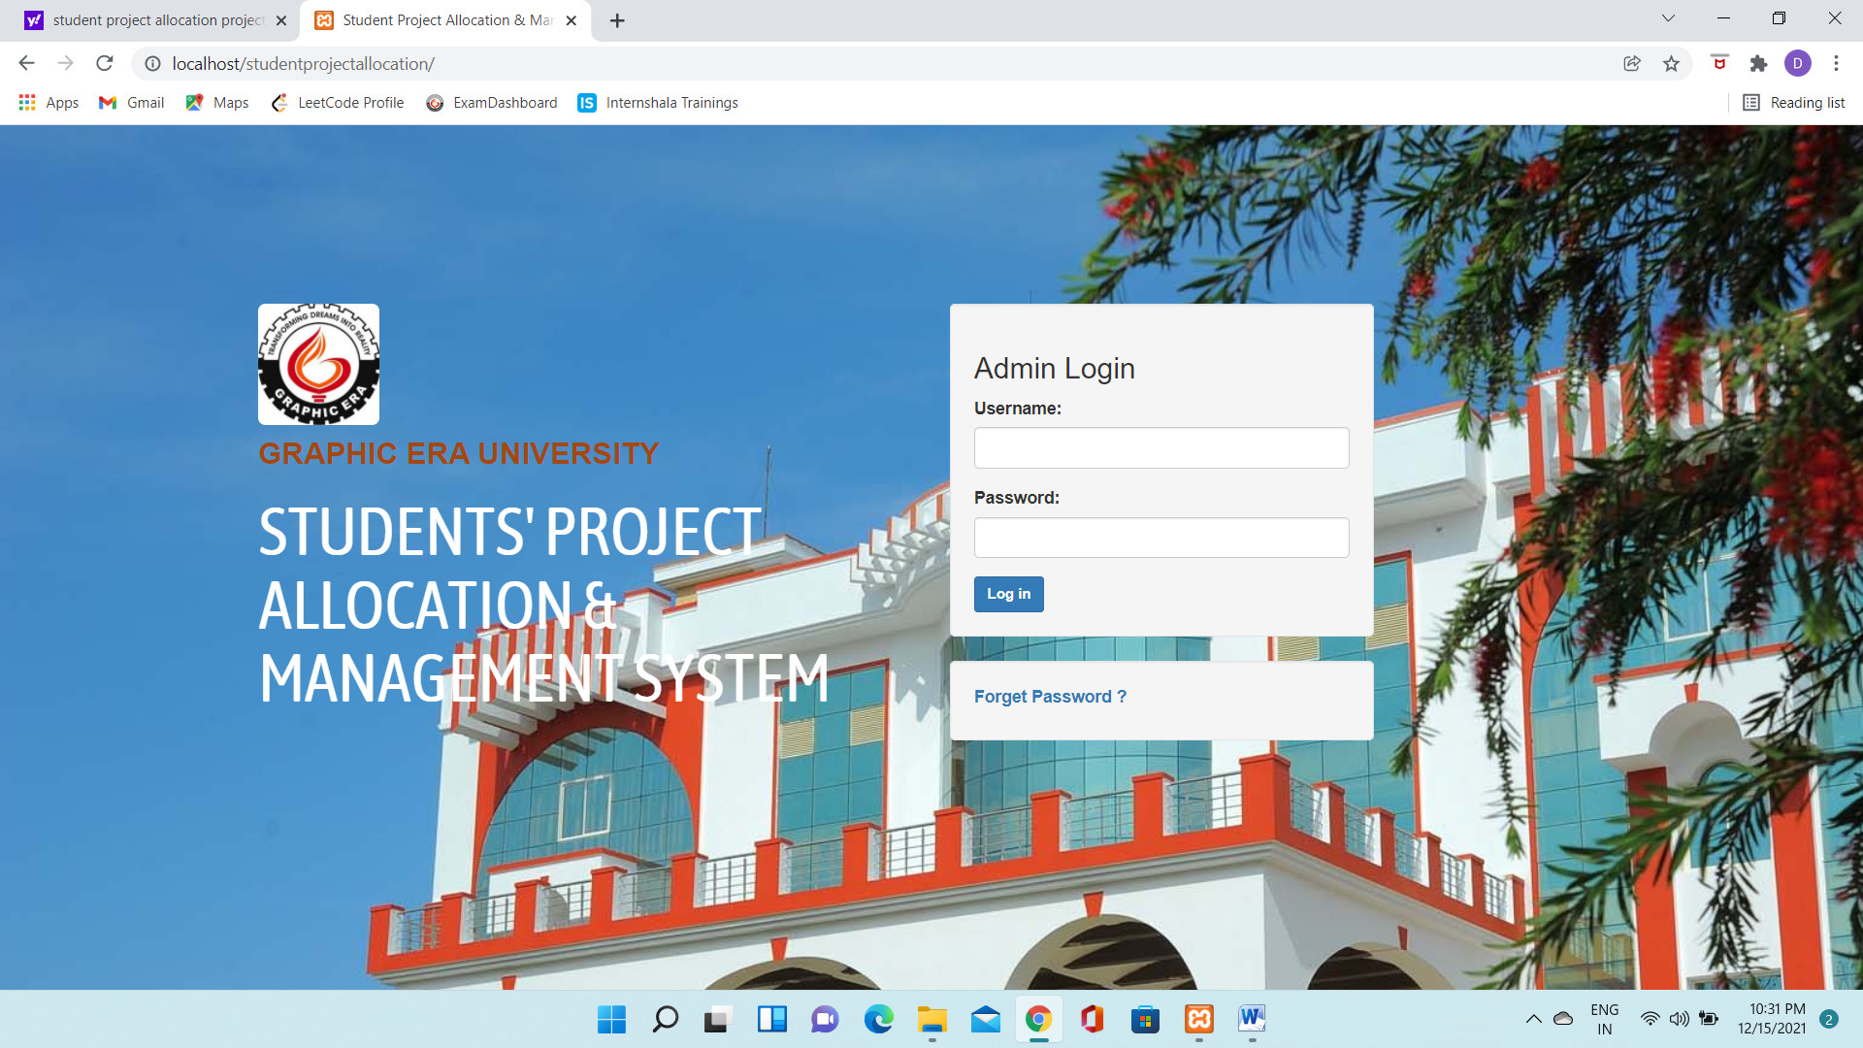

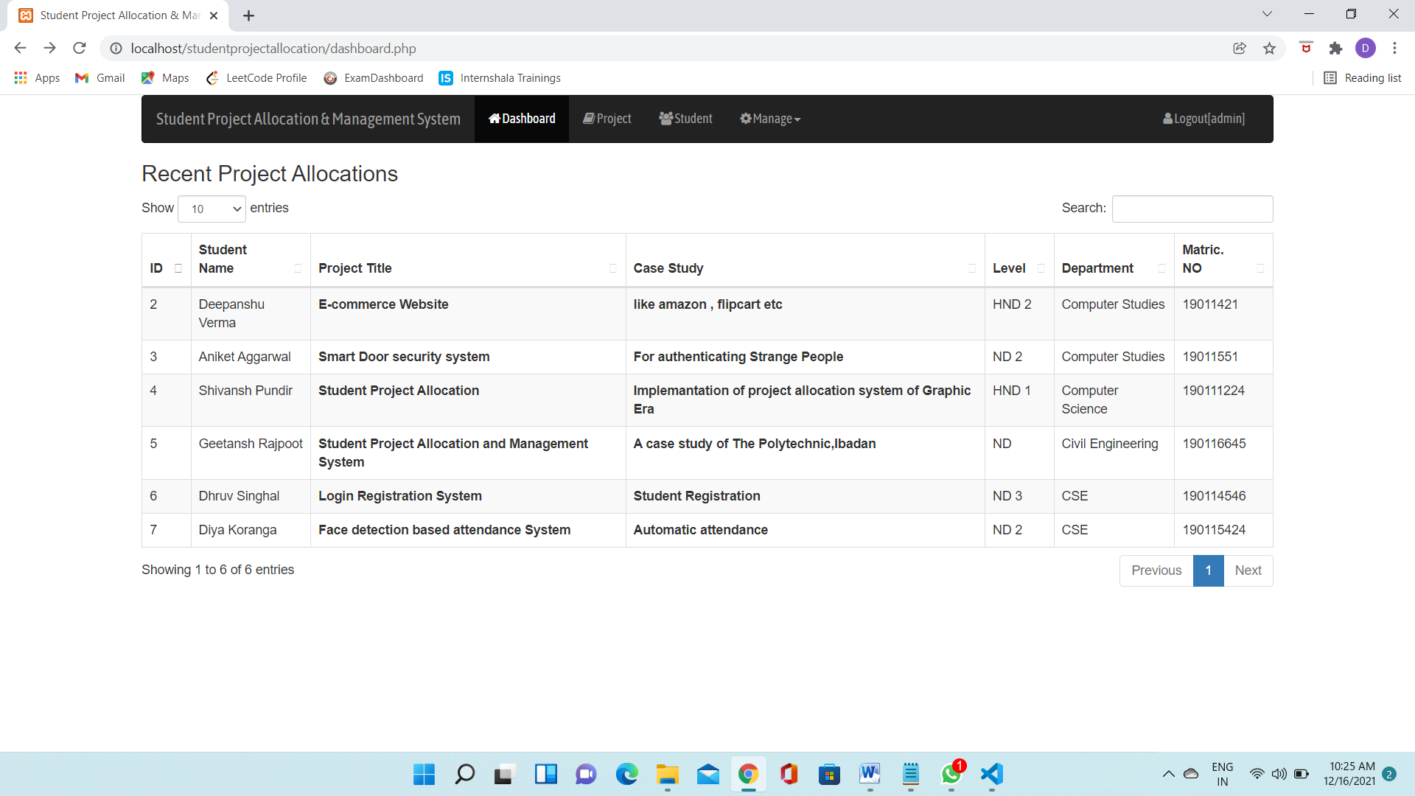

**RESULT ANALYSIS:-**

Students are able to choose the projects in an easy manner allocated by the Graphic Era University. Projects contain extremely valuable information since they report the results of first-hand research information conducted by students within any specific department. it's therefore important for a system to be developed and implemented so as to permit other researchers, students and academic staff, easy and prompt access to the present information. The allocation of projects is an element of a degree course for several tertiary institutions and before the allocation of projects to students is finished, a series of steps have to be followed. Many constraints must be taken into consideration to attain a good allocation. The allocation of project causes many problems as same constraints might not be satisfied. These problems emerge mainly thanks to the increasing number of scholars which results in a rise within the complexity within the allocation of the projects. The aim of this project is to avoid wasting time by producing reports on the assignment of project topics and project supervisors and also develop a far better system which solves these problems or reduce them significantly.

**REFERENCES:**

* Internshala Web Development Program
* [www.php.net](http://www.php.net)
* Javatpoint.com
* getbootstrap.com
* javasript.com